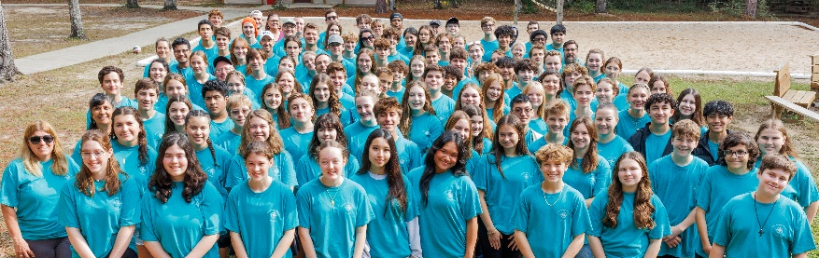
Campout 2025
Amazing (G)Race

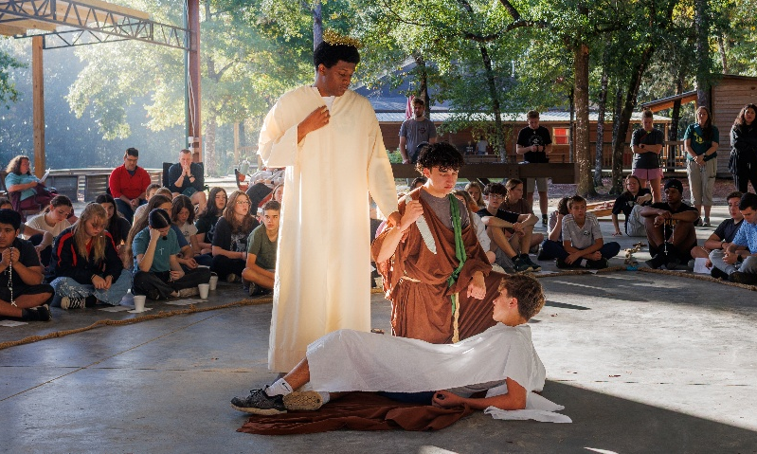
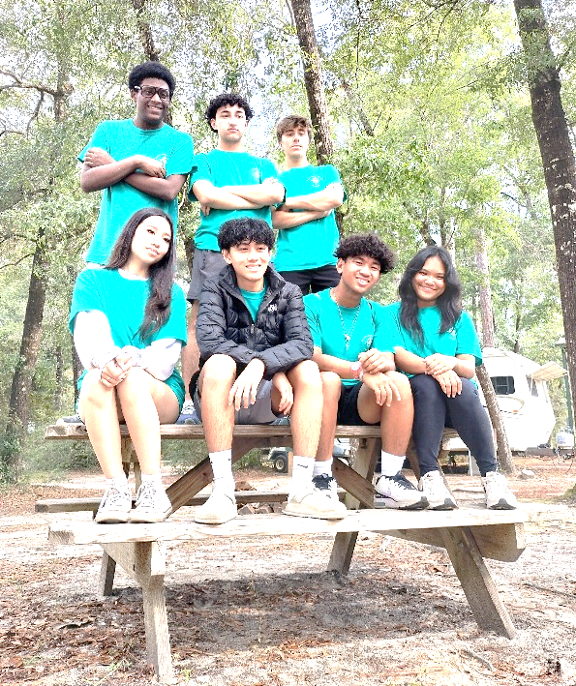
We had a blast at the Diocesan Youth Campout! We all had a great time praying together, diving deep into our faith, and meeting new people from other parishes. The Diocesan Youth Campout isn’t just a place; it’s an experience that makes everyone feel a sense of belonging and love.
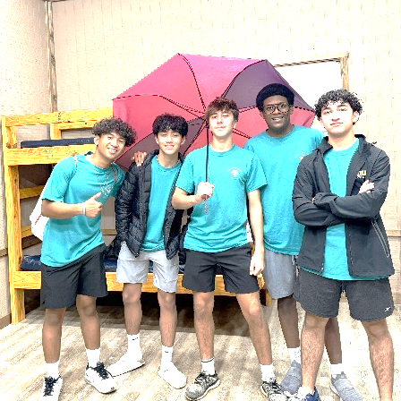

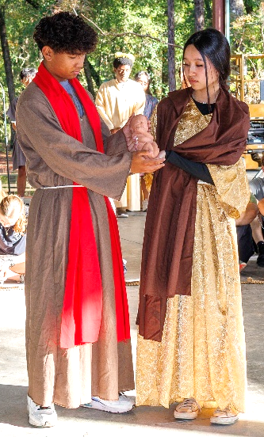
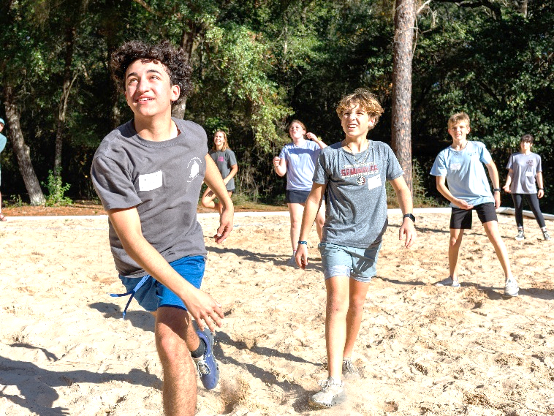

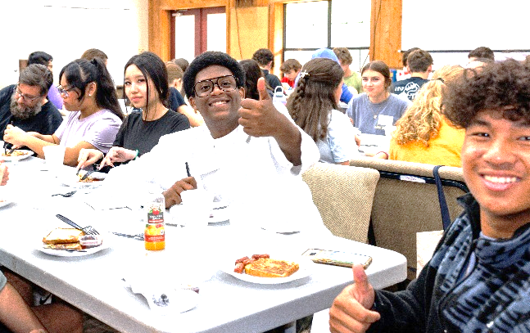

Thanks to your donations in the bake sale, we were able to go to campout, have fun, and grow stronger in our faith. We have many things to say about campout:

I liked being able to meet new people and talk about our faith.
I loved how we got to do adoration and confession.
I liked the meals that they served because they made it with love and it tasted amazing
I liked confession and then going to adoration, it went really well

We liked all the opportunities to grow in faith, yet still do many other things we enjoy. Many of these things included playing Gaga ball, carpet ball, basketball, and pickleball. Along with that, we also did activities like singing, playing cards, making s’mores, and talking with our newly made friends.
Thank you for supporting our high school youth group, SMYLE!

